CPE301 – SPRING 2019

Design Assignment 2A

Student Name: John Duriman

Student #: 5002373995

Student Email: duriman@unlv.nevada.edu

Primary Github address: https://github.com/johnduriman/pirahnaplant.git

Directory: pirahnaplant/Design Assignments/DA2A/

1. **COMPONENTS LIST AND CONNECTION BLOCK DIAGRAM w/ PINS**

ATMEGA328P

1. **INITIAL/MODIFIED/DEVELOPED CODE OF TASK 1/A**
2. **DEVELOPED MODIFIED CODE OF TASK 2/A from TASK 1/A**

Task 1 in C

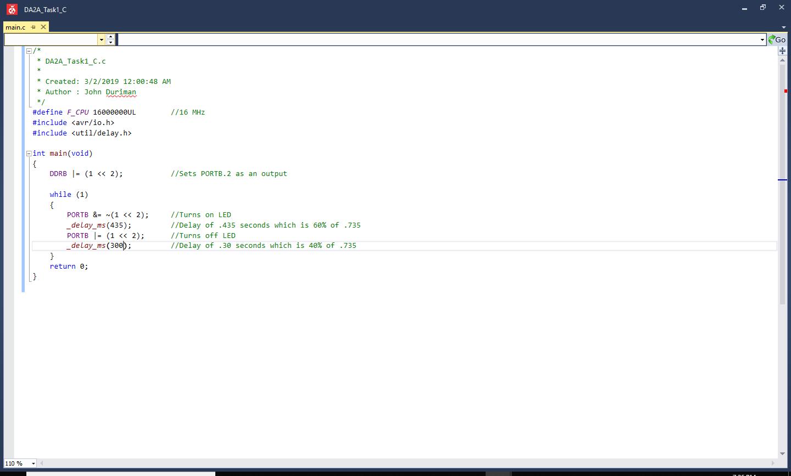

Task 1 in Assembly

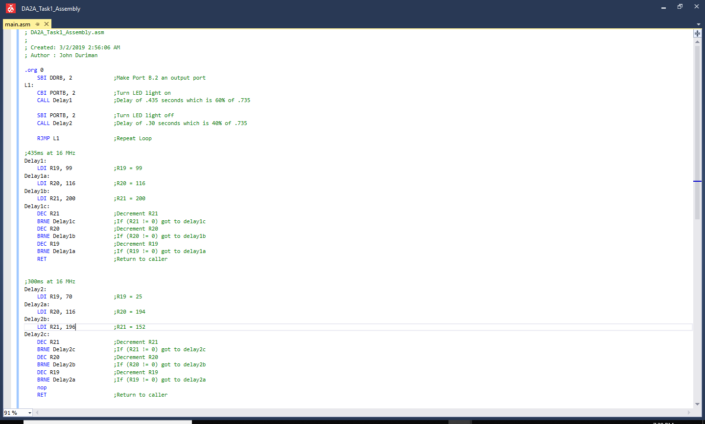

Task 2 in C

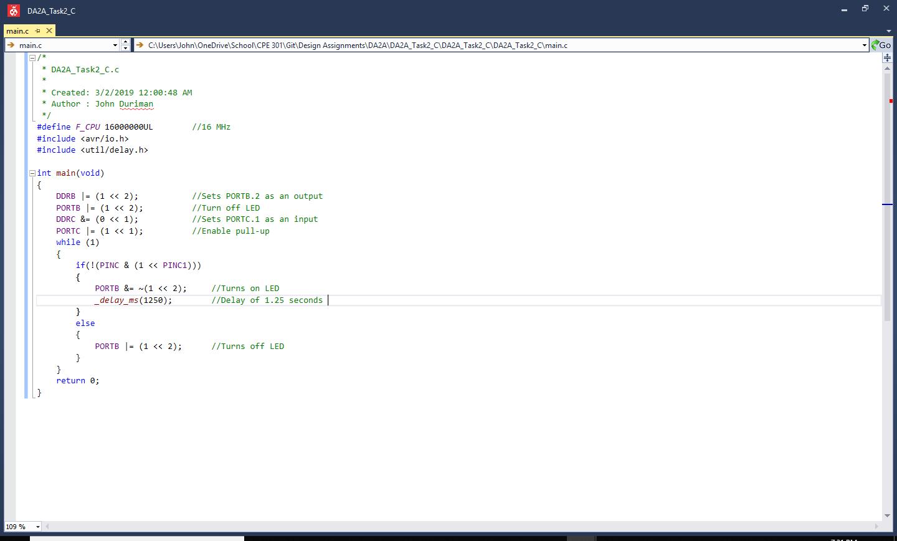

Task 2 in Assembly

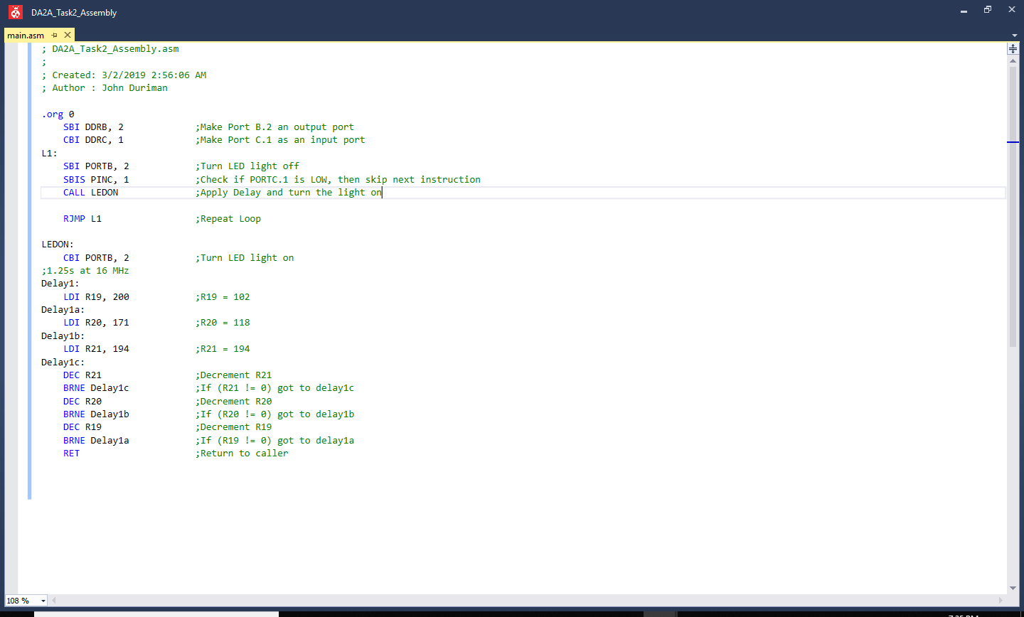

1. **SCHEMATICS**

Use fritzing.org

1. **SCREENSHOTS OF EACH TASK OUTPUT (ATMEL STUDIO OUTPUT)**
2. **SCREENSHOT OF EACH DEMO (BOARD SETUP)**

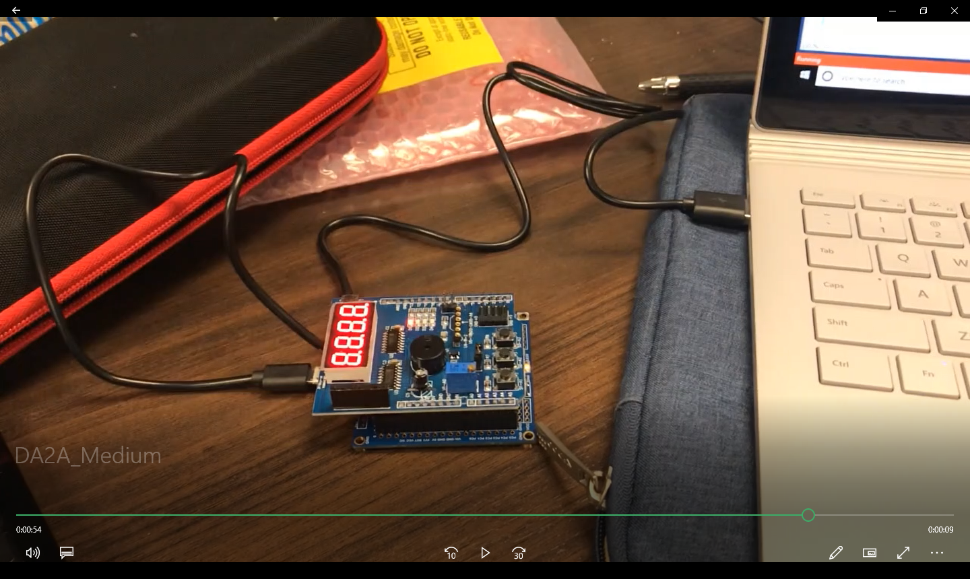

All 4 tasks are setup the same way using the shield on top of the ATMEGA 328P.

They are all blinking the same LED light (rightmost LED light) and Task2 uses the switches on PORT1 as input (bottommost switch in the picture).

1. **VIDEO LINKS OF EACH DEMO**

<https://youtu.be/zaLzdGOSp7E>

1. **GITHUB LINK OF THIS DA**

https://github.com/johnduriman/pirahnaplant.git

**Student Academic Misconduct Policy**

<http://studentconduct.unlv.edu/misconduct/policy.html>

“This assignment submission is my own, original work”.

John Duriman